**Carbon Table 1–Breaking down our FY23 Scope 3 emissions by source**

Microsoft’s Scope 3 emissions continue to account for more than 96% of our total emissions, with the vast majority of these emissions coming from two categories upstream, Purchased Goods and Services (Category 1) and Capital Goods (Category 2), and one downstream, Use of Sold Products (Category 11).

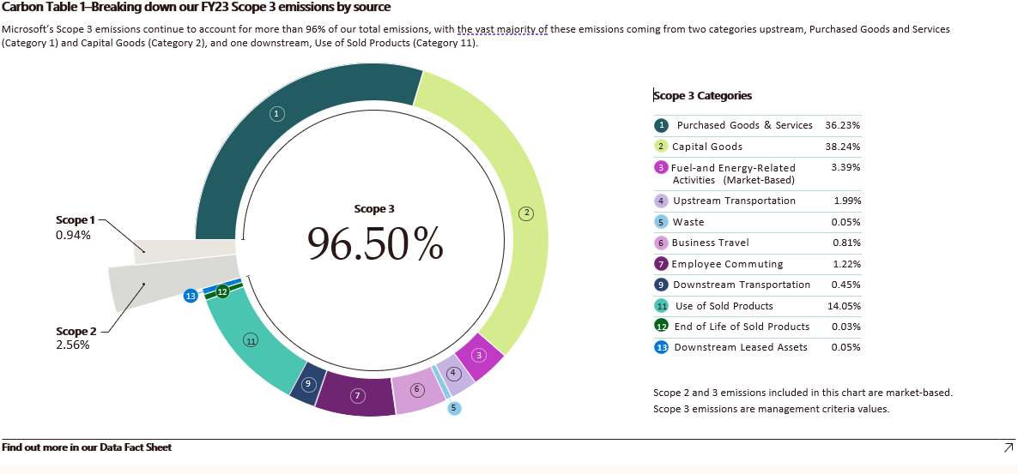

Donut charts showing the percentage of FY23 Scope 3 emissions. Percentages of Scope 1, Scope 2, and Scope 3 emissions are 0.94%, 2.56%, and 96.50% respectively. Among the categories of Scope 3, Purchased Goods & Services: 36.23%, Capital Goods: 38.24%, Fuel- and Energy-Related Activities (Market-Based): 3.39%, Upstream Transportation: 1.99%, Waste: 0.05%, Business Travel: 0.81%, Employee Commuting: 1.22%, Downstream Transportation: 0.45%, Use of Sold Products: 14.05%, End of Life of Sold Products: 0.3%, and Downstream Leased Assets: 0.05%.